Annual Vessel Registration and State Ramp Use Decals for 2025

Scope of Work

The contractor shall provide all labor and material as specified herein.

Description

The reflective sheeting shall consist of lens elements enclosed within a transparent resin and shall have a pre-coated pressure sensitive adhesive backing protected by a removable liner. The retro-reflective sheeting shall provide a weather resistant, essentially smooth, flat, outer surface when finished with material in the manner recommended by the retro-reflective sheeting manufacturer.

A. RETRO-REFLECTIVE SHEETING REQUIREMENTS

1.0 Reflective Characteristics

The unprinted retro-reflective sheeting shall have the following minimum brightness values expressed as average candlepower per square foot of material. Measurements shall be conducted in accordance with the reflective intensity testing procedures for reflective sheeting specified in federal specification LA-300C, “Sheeting and Tape, Reflective: Non-Exposed Lens, Adhesive Backing”, Para. 4.4.7.

White
Observation Angles 0.2 0.5

Entrance Angles -4 30.0 18.0
40 6.0 5.0

2.0 Rainfall Performance

The brightness of the sheeting, totally wet by rain, shall not be less than 90% of the above values. Wet performance measurements shall be conducted at 0.2 observation and -4 entrance in accordance with the rainfall test method specified in federal specification LS-300C, “Sheeting and Tape Reflective: Non-Exposed Lens, Adhesive Backing”, Para. 4.4.9.4.

3.0 Adhesive

3.1 The pre-coated pressure sensitive adhesive shall form a durable vandal resistant bond to clean, dry, painted, varnished, fiberglass, aluminum, or steel surfaces. Surfaces may be moderately rough, pitted or waxed.

3.2 The protective liner attached to the adhesive shall be removed by peeling without soaking in water or other solvents and shall be easily removed after accelerated storage for four hours at 150°F under weight of 2.5 lbs. per square inch.

3.3 The adhesive shall not exude from edges of the sheeting when processed into the finished decal so as to cause stacked pieces to stick together during shearing, cutting, printing, handling, or while packaged in shipment and distribution.

4.0 Film

4.1 The sheeting shall have a similar diffuse (daytime) and reflected (night time) color.

4.2 The sheeting surface shall be readily cut/diecut without cracking, or flaking, and shall be compatible with transparent or opaque inks and protective finishing clear as designed and supplied by the reflective sheeting manufacturer for decal fabrication.

4.3 The decals processed and applied in accordance with the recommendations of the reflective sheeting manufacturer shall be easily cleansed of normal direct accumulation by washing with water and mild detergent. The surface shall be sufficiently solvent resistant to permit cleaning with solvents such as VW&P naphtha, mineral spirits, turpentine or other solvents commonly used on vessel finishes. Rinsed and dried, the surface shall show no appreciable change following cleaning when compared to a new clean decal surface.

4.4 Protective finished clear coating shall remain clear and durable as well as provide a compatible surface for direct application of additional registration decals.

5.0 Physical Characteristics

Retro-reflective sheeting shall be free from ragged edges, cracks, and blisters and be packaged in accordance with accepted commercial standards. Decals shall have a service life of a minimum of twelve (12) months.

B. FABRICATION REQUIREMENTS

  - Item No. 1: Annual Vessel Registration Decal

  - Design, Color and Size

The size, shape and design of the decals, as well as the size and position of all printing, shall be in strict conformity with the attached sample and the following requirements.

The vessel registration decal shall have a background sheeting of “Confirm” brand security film No. 4230 (white). The border and wording shall be reversed printing with “Scotchlite” brand transparent process color blue or a material of equal quality. Finished decal must be clear coated with “Scotchlite” brand clear coat No. 260 or a material of equal quality.

All wording and numerics shall be printed with “Scotchlite” brand process color No. 200 (black) or a material of equal quality. The “month number” shall be followed by a slash, the year of the decal expiration shall be “25”.

The dimensions of each decal shall be three inches (3.0”) per side.

The adhesive protective liner on sheeting intended for fabrication of individual decals shall be scored at or near the center of each sticker for easy removal.

1.2 Registration Number

Decals shall be manufactured in pairs, and each pair shall have identical registration numbers and must be easily separated.

Each pair of decals shall be printed with a registration number running consecutively shown in the table below. The registration number shall be printed with “Scotchlite” brand process color No. 200 (black) or a material of equal quality. Design and size of registration numbers to be approved by the user. (See example illustration, Item No. 1).

1.3 Quantity

Month | Beginning  Registration  Number | Ending  Registration  Number | Amount  (pairs)
1 | C00001 | C01600 | 1600
2 | C01601 | C03100 | 1500
3 | C03101 | C04900 | 1800
4 | C04901 | C06800 | 1900
5 | C06801 | C08700 | 1900
6 | C08701 | C10800 | 2100
7 | C10801 | C12900 | 2100
8 | C12901 | C14900 | 2000
9 | C14901 | C16600 | 1700
10 | C16601 | C18300 | 1700
11 | C18301 | C20100 | 1800
12 | C20101 | C22000 | 1900

1.4. Barcode

The decal shall contain a 2D UPC barcode which reads the following information shown in quotes and from the table above as follows: (1) the registration number in sequential order beginning with “C00001”; and, (2) the corresponding month/year beginning with “1/25”.

2.0 Item No. 2: State Ramp Use Decal

2.1 Design, Color and Size

The size, shape and design of the decals, as well as the size and position of all printing, shall be in strict conformity with the attached sample and the following requirements.

The state ramp use decal shall have a background sheeting of “Confirm” brand security film No. 4230 (white). The border shall be reversed printed with “Scotchlite” brand transparent process color blue or a material of equal quality. Finished decals must be clear coated with “Scotchlite” brand clear coat No. 260 or a material of equal quality.

All wording and numerics shall be printed with “Scotchlite” brand process color No. 200 (black) or a material of equal quality. The “month number” shall be followed by a slash, the year of the decal expiration shall be “25”.

The dimensions of each decal shall be three inches (3.0”) per side.

The adhesive protective liner on sheeting intended for fabrication of individual decals shall be scored at or near the center of each sticker for easy removal.

2.2 Ramp Number

Decals shall be manufactured in pairs, and each pair shall have identical ramp numbers and must be easily separated.

Each pair of decals shall be printed with a ramp number running consecutively shown in the table below. The ramp number shall be printed with “Scotchlite” brand process color No. 200 (black) or a material of equal quality. Design and size of ramp numbers to be approved by the user. (See example illustration, Item No. 2).

2.3 Quantity

Month | Beginning  Ramp  Number | Ending  Ramp  Number | Amount  (pairs)
1 | C30001 | C31400 | 1400
2 | C31401 | C32800 | 1400
3 | C32801 | C34300 | 1500
4 | C34301 | C35900 | 1600
5 | C35901 | C37500 | 1600
6 | C37501 | C39300 | 1800
7 | C39301 | C41000 | 1700
8 | C41001 | C42600 | 1600
9 | C42601 | C44000 | 1400
10 | C44001 | C45300 | 1300
11 | C45301 | C46800 | 1500
12 | C46801 | C48300 | 1500

2.4. Barcode

The decal shall contain a 2D UPC barcode which reads the following information shown in quotes and from the table above as follows: (1) the ramp number in sequential order beginning with “C30001”; and, (2) the corresponding month/year beginning with “1/25”.

APPLICATION INSTRUCTION

Application instructions shall be printed on the back of each pair of decals. See attached sample for printing of application instructions.

RESPONSIBILITY

The successful sheeting bidder shall furnish all inks, clear coating, and thinners needed to produce boat registration decals meeting the requirements of this specification.

SECURITY MEASURES

The Contractor must provide adequate security methods and supervision to protect decals from hazard or loss. A complete description of the plant security precautions must accompany each bid. The State reserves the right to enter the vendor’s premises at any time during the production of decals to inspect the progress of production, the quality of workmanship, and the adequacy of security.

WORKMANSHIP

All workmanship shall be first class and done in accordance with generally accepted decal manufacturing standards.

WARRANTY

The decal manufacturer shall certify that all decals furnished conform to the specifications herein. The decal manufacturer shall replace all defective decals without further expense to the State.

PACKAGING

Decals shall be packaged in such a manner as to prevent sticking or damaging of printed surface while in transit or in storage.

DELIVERY

Delivery shall be made within 45 calendar days from the date indicated in the Notice to Proceed.

PAYMENT

Payment shall be made in lump sum to the vendor awarded the contract. Payment shall include labor, materials, State and Federal taxes and delivery.

K. GUARANTEE

The vendor shall submit a statement guaranteeing that the decals he furnished will be free of any defective material of workmanship for a period of 12 months from the date of delivery. The vendor shall further agree to furnish, at no cost to the State, labor and materials for replacement decals in which defects appear within the guarantee period.

Item No. 1
Annual Vessel Registration Decal

(Front)
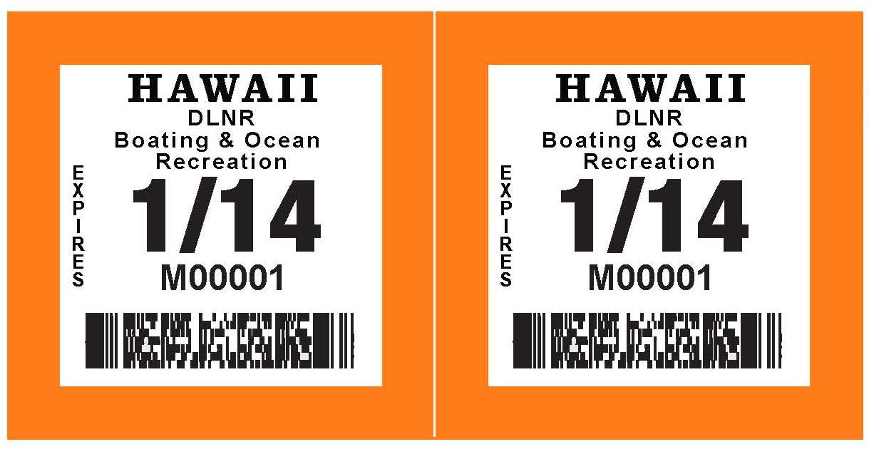
3”
6”

(Back)
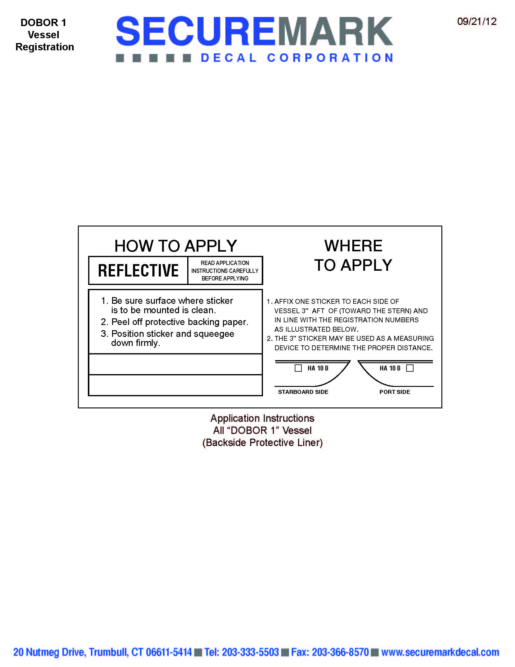

Item No. 2
State Ramp Use Decal

(Front)
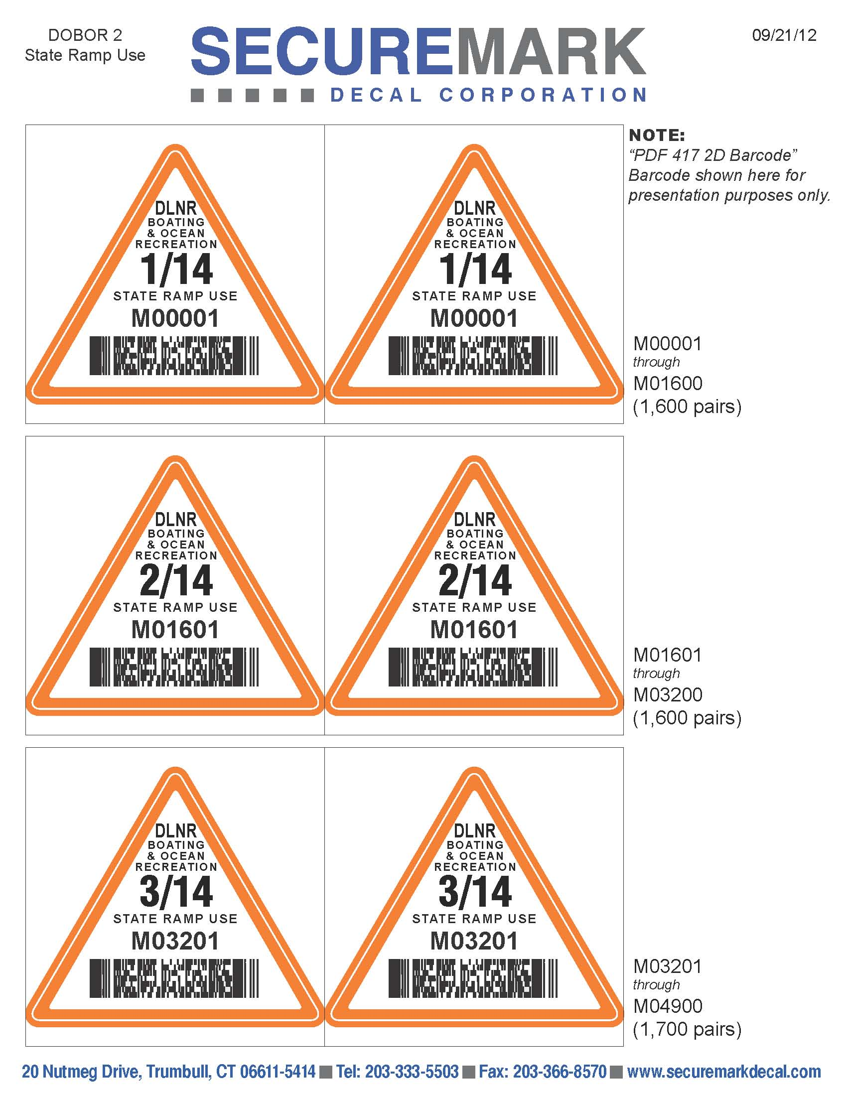
3”
6”

(Back)
